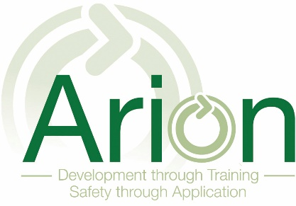

Arion Training and Development Ltd
Data Protection
18

Policy Section Number | 18
Date Ratified | 01/04/2020
Version Number | 1
Next Review Date | 01/04/2021
Related Policies and Guidance Documents | All policies included
Related Regulations
Annexes and Supplementary Info | None
Responsible Person | Russ Pryor
Responsible Person Signature | 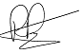

Company Data Protection Statement

This section of the policy has been written to aid staff in identifying and complying with data protection principles.

Arion Ltd needs to collect certain data and information from persons with whom it deals with, in order to operate. This includes from staff, delegates and clients.

This personal information will be dealt with properly, however it is collected, recorded and used – whether on paper, electronically, or other means.

This data is protected electronically through password protection and access restricted to name staff only. Hard copy is similarly stored, protected through physical security means, with limited access rights.

Arion Training & Development Ltd are committed to:

- Ensuing compliance to the data protection principles.
- Meeting legal obligations as laid down by the Act.
- Ensuring that data is collected and used fairly and lawfully
- Processing personal data only in order to meet our operational needs or fulfil legal requirements
- Taking steps to ensure that personal data is up to date and accurate
- Establishing appropriate retention periods for personal data
- Ensuring that data subjects' rights can be appropriately exercised
- Providing adequate security measures to protect personal data
- Ensuring that a nominated officer is responsible for data protection compliance and provides a point of contact for all data protection issue
- Ensuring that all staff are made aware of good practice in data protection
- Providing adequate training for all staff responsible for personal data
- Ensuring that everyone handling personal data knows where to find further guidance
- Ensuring that queries about data protection, internal and external to the organisation, is dealt with effectively and promptly
- Regularly reviewing data protection procedures and guidelines within the organisation

To this end, we fully endorse and adhere to the principles of data protection, as set out in the General Data Protection Regulation (GDPR.

The principles require that personal information:
- Shall be processed fairly and lawfully and, in particular, shall not be processed unless specific conditions are met; We will only process and store information which is required to register students, monitor their progress and notify them of similar activities and training, or refreshers and updates.

- Shall be obtained only for one or more specified and lawful purposes and shall not be further processed in any manner incompatible with that purpose or those purposes; we will only process information relevant to the monitoring and training of an individual.

- Shall be adequate, relevant and not excessive in relation to the purpose or purposes for which they are processed; we will only collect information, which is required by awarding bodies for registration, examination etc. and by Arion Training & Development for continued monitoring and training purposes.

- Shall be accurate and, where necessary, kept up to date; Information will be checked for accuracy prior to any processing, following original collection.

- Shall not be kept for longer than is necessary for the specified purpose(s); information will be removed when no longer required by the individual concerned.

- Shall be processed in accordance with the rights of data subjects under the Act.

- Should be subject to appropriate technical and organisational measures to prevent the unauthorised or unlawful processing of personal data, or the accidental loss, destruction, or damage to personal data.

