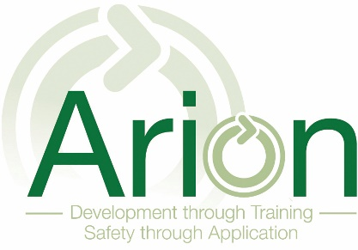

Arion Training and Development Ltd
Quality Control
30

Policy Section Number | 30
Date Ratified | 01/04/2020
Version Number | 1
Next Review Date | 01/04/2021
Related Policies and Guidance Documents | All policies included
Related Regulations
Annexes and Supplementary Info | None
Responsible Person | Russ Pryor
Responsible Person Signature | 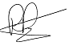

Company Quality Policy Statement

Arion Training and Development Ltd is dedicated to a quality policy and standard that will ensure that its products and services fully meet the requirements of its customers at all times. The goal of the Company is to achieve the highest level of customer satisfaction at all times. Our commitment to the implementation of supporting managerial and business operational systems is essential to realising that goal.

Arion Training and Development Ltd believes in the concept of client and supplier working together in pursuing this policy and in continually striving for improvements in service quality.

Our quality policy is based on 4 fundamental principles:

- Ensuring that we fully identify and conform to the needs of our customers.
- Looking at our service provision and manufacturing processes, identifying the potential for errors and taking the necessary action to eliminate them.
- Everyone understanding how to do their job and doing it right first time.
- Ensuring everyone is properly trained and equipped to carry out their role.
To ensure that the policy is successfully implemented, staff will be responsible for identifying customer requirements, and ensuring that the correct procedures are followed to meet those requirements.

Objectives needed to ensure that the requirements of this policy are met, and that continual improvement is maintained in line with the spirit of the policy, will be set, determined and monitored at Management Review.

The quality policy principles and objectives will be communicated and available to staff at all times. Training will be an integral part of the strategy to achieve our objectives.

Within this Policy we are committed to operating our Company under the disciplines and control of a Quality Management System while encouraging innovation and challenge amongst all of our staff.

We recognise that our staff are vital to the success of our quality system as they play an integral part of manufacturing and service delivery. It is for this reason that we follow a programme of continuous improvement with a planned programme of training and development designed to empower and encourage our staff to achieve the Company goals.

We are all committed to operating continuously to the highest standards and we will maintain these in order to meet and exceed our customer requirements.

Our Company will constantly review and improve on our services to ensure tasks are completed in the most cost effective and timely manner for the benefit of all our customers.

We shall ensure that all our personnel understand and fully implement our Company's policies and objectives and are able to perform their duties effectively through an on-going training and development programme.

